City Loop upgrades

The Victorian Government is delivering major upgrades to the City Loop to improve the management of emergency situations at Flagstaff, Melbourne Central and Parliament stations. These works will involve installing modern smoke detection, extraction, and sprinkler systems at these three stations.

The City Loop has been at the heart of Melbourne’s
train network for four decades.
Construction of the City Loop began in the 1970s and its infrastructure needs to be regularly maintained and upgraded.
Crews will work until late 2023 to install modern smoke detection, extraction and sprinkler systems at Flagstaff, Melbourne Central and Parliament stations to improve the management of emergency situations.
These important safety upgrades will keep this crucial asset up to date with modern operating standards.
Works taking place
We will undertake the following works at Flagstaff, Melbourne Central and Parliament stations to upgrade the City Loop:
- Upgrade vent shafts
- Replace existing cladding and ceiling panels with new ones that meet current standards
- Install smoke barriers at cross passages and escalator openings
- Install new security grilles and fire detection sensors
- Upgrade emergency communication systems
- Upgrade fire sprinkler systems
- Upgrade backup power generation systems.

Changes to travel during construction
To complete works safely, there will be a number of City Loop weekend closures from now until mid-2023.
During these weekend closures, two loops will always remain open, which means passengers can still travel to their chosen destination through the City Loop.
In January 2023, when passenger numbers are lower, the City Loop will completely shut for two weeks from 9pm Monday 2 January to first services on Monday 16 January.
While the City Loop is closed, crews will undertake major works to install modern smoke detection, extraction and sprinkler systems at Flagstaff, Melbourne Central and Parliament stations, and decommission existing outdated infrastructure.
At times, there may be temporary or intermittent road and lane closures and changes to parking and pedestrian access around the City Loop stations.
Traffic management will be in place to guide drivers and pedestrians safely, and passengers will be notified of any changes to the City Loop ahead of time.
What to expect during construction
- Noise and dust from construction machinery such as cranes
- Increased activity from workers, vehicles, and construction equipment
- Increased signage, fencing and traffic management controls to help you move safely through the area.
Stay in touch
The Level Crossing Removal Project is delivering these works on behalf of the Victorian Government.
If you have any questions about the project, please email contact@levelcrossings.vic.gov.au or call 1800 105 105.
For further information on disruptions, please
visit ptv.vic.gov.au or call 1800 800 007
to plan your journey.
Project timeline
Mid 2022
- Site establishment and early works start
- Select weekend loop closures begin with two tunnels operating at all times
Early January 2023
- City Loop closed for two weeks
Late 2023
- Works complete

*Timeline subject to change

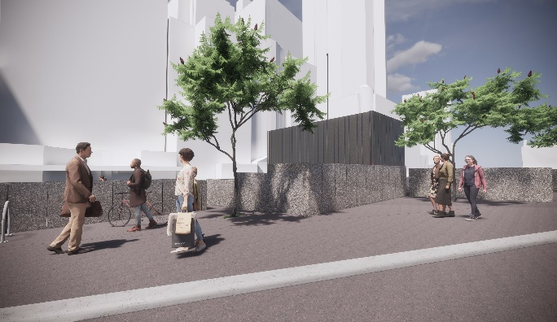
Upgraded vent at Parliament north. Artist impression – subject to change.

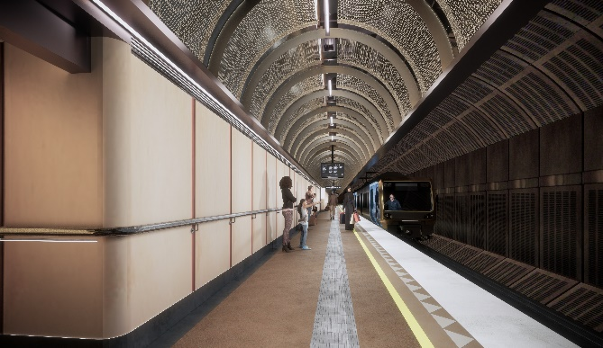
Upgraded platform at Flagstaff station. Artist impression – subject to change.

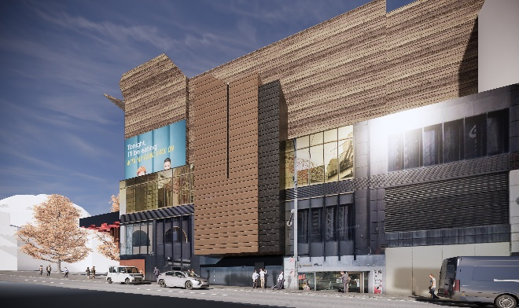
Upgraded vent at Melbourne Central east. Artist impression – subject to change.

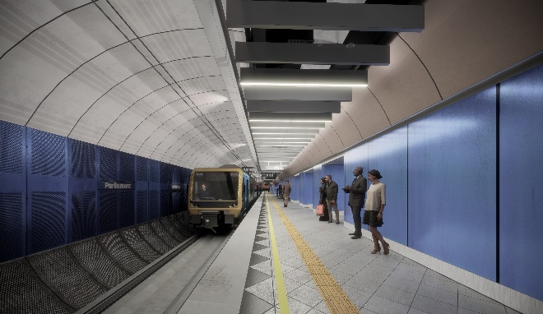
Upgraded ceiling battens at Parliament station platform.
Artist impression – subject to change.

Plan ahead at ptv.vic.gov.au or call 1800 800 007.
If you’re deaf, or have a hearing or speech impairment, contact us through the National Relay Service – for more information, visit relayservice.gov.au
For other languages visit ptv.vic.gov.au/languages or call 9321 545

